POI 2:

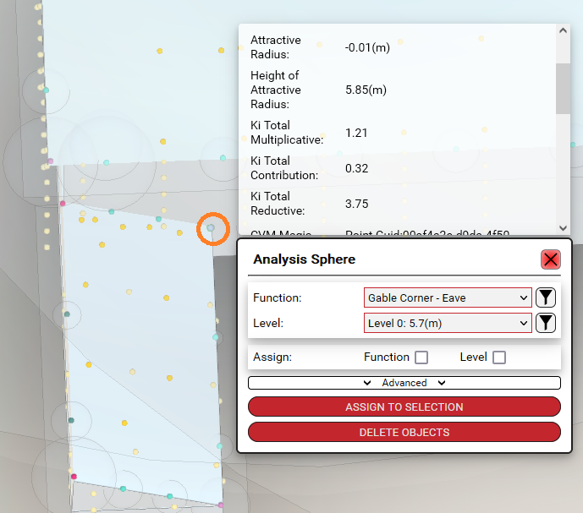

POI 2 pulls not extended **@Carlo**

POI 5:



POI 5 not pulling extended **@Carlo**

POI 6:

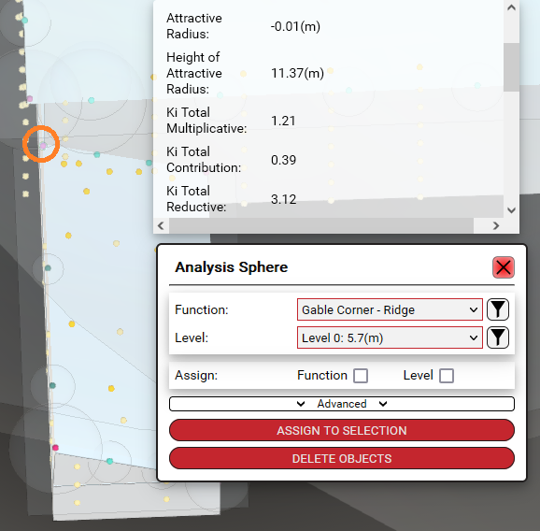

POI 6 pulls not extended @Carlo

POI 11:

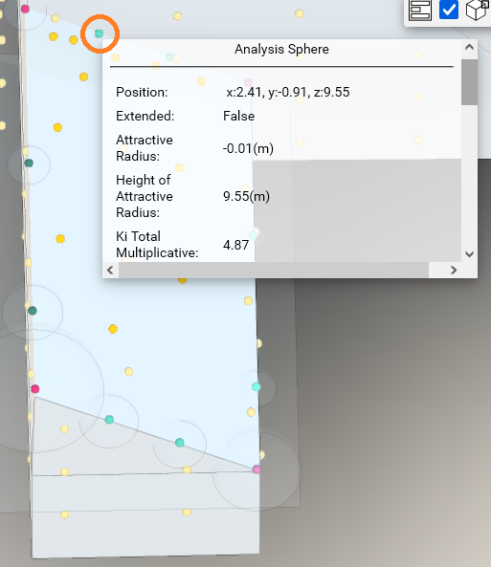

I think these are pulling GRN but I’m not concerned about 11 & 12

POI 12:



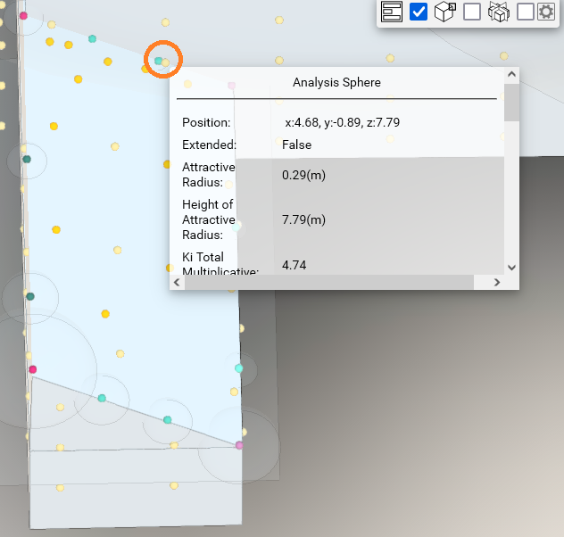

I think these are pulling GRN but I’m not concerned about 11 & 12

POI 41-42:

Slope not calculated on these points **@Carlo**

POI 53:

POI not pulling extended **@Carlo Marsden**

POI MAP:

